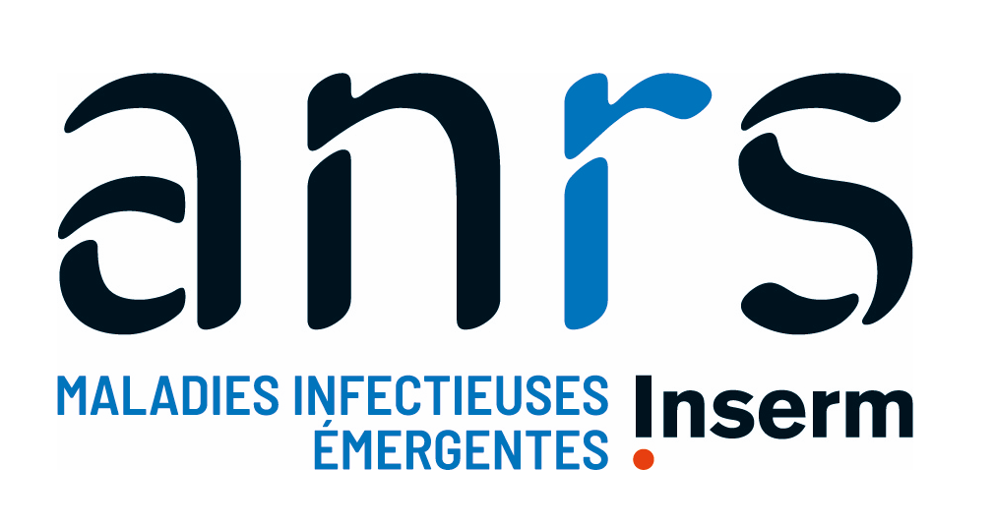

Fellowship Programme 2024
« PhD Grant – Arbo-France »

Application form
Document C1

Research Topic (only one choice possible):
Open topic on arbovirology ☐
Animal component of arboviral infections ☐
Population health intervention research* on human arboviroses ☐
Other ☐

*Population health intervention research (PHIR) involves the use of scientific methods to produce knowledge about policy and program interventions that operate within or outside of the health sector and have the potential to impact health status and health equity at the population level.

Candidate information:
Civility:
Name:
First name:

Project Title:

PhD supervisor (name and laboratory):
Date of « HDR » for the PhD supervisor:
Institution in charge of administration and finance for the laboratory:
If co-supervision
PhD co-supervisor (name and laboratory):
Date of « HDR » for the PhD co-supervisor:
Institution in charge of administration and finance for the laboratory:

Is the PhD supervisor different from the laboratory Director?
If yes, the laboratory Director:

Number of research fellows currently in the laboratory
PhD students:
Post-Doctoral fellows:
Number of research fellows funded by ANRS MIE:

Detailed description of the project
(in English – at most 4 pages)

What is expected and will be the subject of evaluation:
- The project: its innovative and original nature, its excellence in relation to the state of science, the clarity of its objectives, feasibility, as well as its collaborative dimension, with particular attention given to applications for co-supervised thesis;
- The candidate: their expertise and academic background, and their suitability with the presented project, their motivation for the project, the prospects they present to continue their career in this field;
- The quality and expertise of the hosting structure.

- Scientific background to the project and state of the art in the field

- Questions addressed in the project : working hypotheses

- Detailed description of the proposed project
What is expected here:
- Rational / Methods used
- Preliminary results, if any, of the host team and/or the applicant, if relevant
- Study population, participant selection criteria, if relevant
- Conditions for setting up the research and feasibility (regulatory approvals, infrastructure, research funding, feasibility in the time available)

- Expected results

- Research timeline (1 figure)

Please note: The bibliography must be provided in a separate annex to be uploaded into Apogée (Scientific part > Detailed description of the project > Bibliography).

