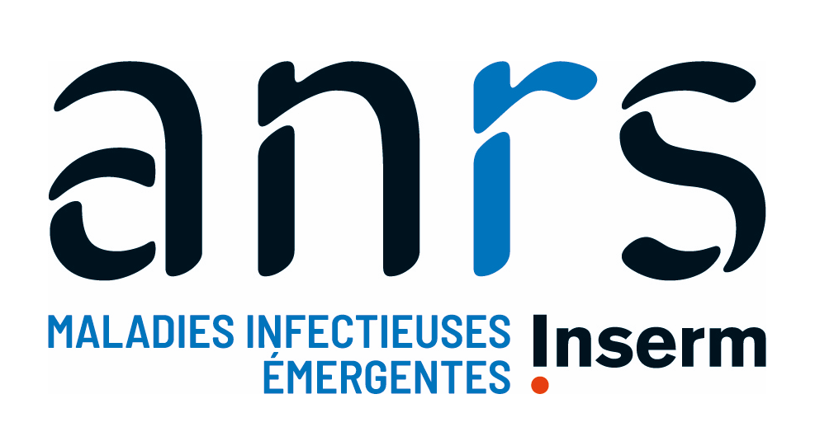

Fellowship Programme 2024
“Master Scholarships – International Network”

Application form
Document A1

The shaded areas are indicative to signal the areas to be filled in; their size is flexible and they can be adjusted according to the length of the responses provided by the candidates.

Candidate Information

Surname:
First Name:
Title:
Nationality:
Date and Place of Birth:
Marital Status:
Home Address:
Country:
Contact Email:

Current Professional Situation:

Master's degree required
Specify the full title of the master's degree, the name, city, and country of the institution

- Previous Experiences

  - Educational Background

Previous studies and diplomas obtained
Add lines as needed

Year | Diploma | Institution name  and place | Ranking / Honours

Other studies/training not leading to a diploma

  - Professional experience relevant to this scholarship application

Add lines as needed
Dates | Organisation / country | Position Title and Main Activities | Reference (name, position, email)

  - Connection with a Partner Site or PRISME of the ANRS MIE International Network

If you have already collaborated with a Partner Site or PRISME, present here in what context and what type of collaboration (project management, internship, research project, or any other collaboration).

If you have never collaborated with a Partner Site or PRISME, explain your motivation to initiate this collaboration, the exchanges you have had, and the form it will take.

  - Articles, oral communications or posters, documents, reports, that you have produced or been associated with

- Project and Career Perspectives (maximum 4 pages)

  - Master's Project

Present your master's project here: desired master's degree, envisaged internship project, reasons for this choice and coherence with your background and experiences mentioned above, etc.
This part can include the main points of your motivation letter.

If an equivalent master's program to the one for which you are applying for a scholarship exists in your country of residence, justify the reasons for this scholarship application.

Note:
- If your internship is already found, explain the conditions under which it will take place (location, host team, period, subject, supervisor, etc.)
- If you do not yet have an internship, highlight the type of internship you would like to find (structure, subject, initiated research, etc.)

Have you applied for other funding opportunities for the master's project presented above?

Have you applied for other courses / training than the one presented here for 2024-2025?

  - Career Perspectives

In the light of the project presented above, please explain here the perspectives you would like to give to your career: what are your professional objectives and projects after obtaining this Master's degree? What themes would you like to work on?

